:: To install Dbus in ubuntu 18.04 & Eclipse ::

- First run following command in terminal :
sudo apt-get install libdbus-1-dev libdbus-glib-1-dev
- After this run following command in terminal:
pkg-config --cflags glib-2.0 dbus-1
- Copy path of installed bdus from terminal like below screenshot:
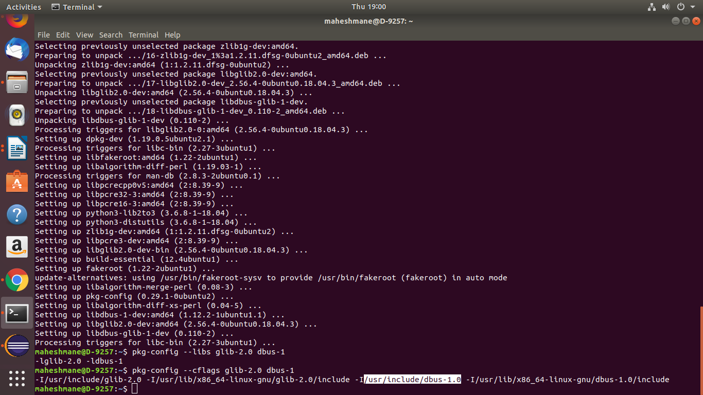

- Paste above path in eclipse like below:
